Start with a general island shape. Make sure the top is filled in with a face.

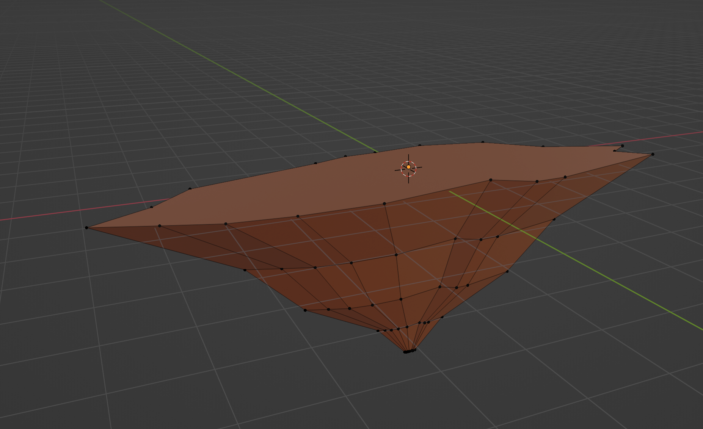

Add a Remesh modifier. Set it to “Sharp” and set the Octree Depth to around 6 or 7, depending on the size of the island.

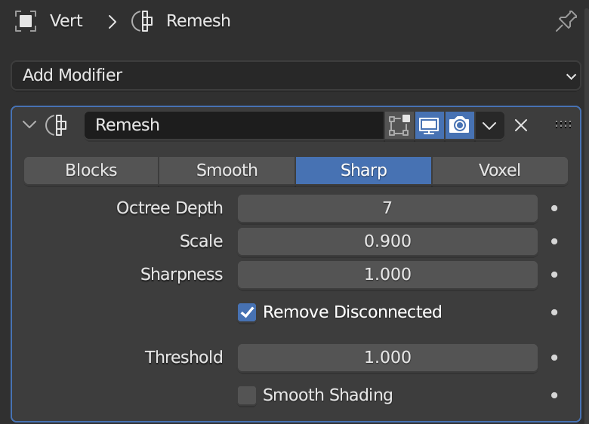

Add a displace modifier. Then add a new texture, name is whatever. I named mine “Rock”.

Then navigate to the Texture Properties tab

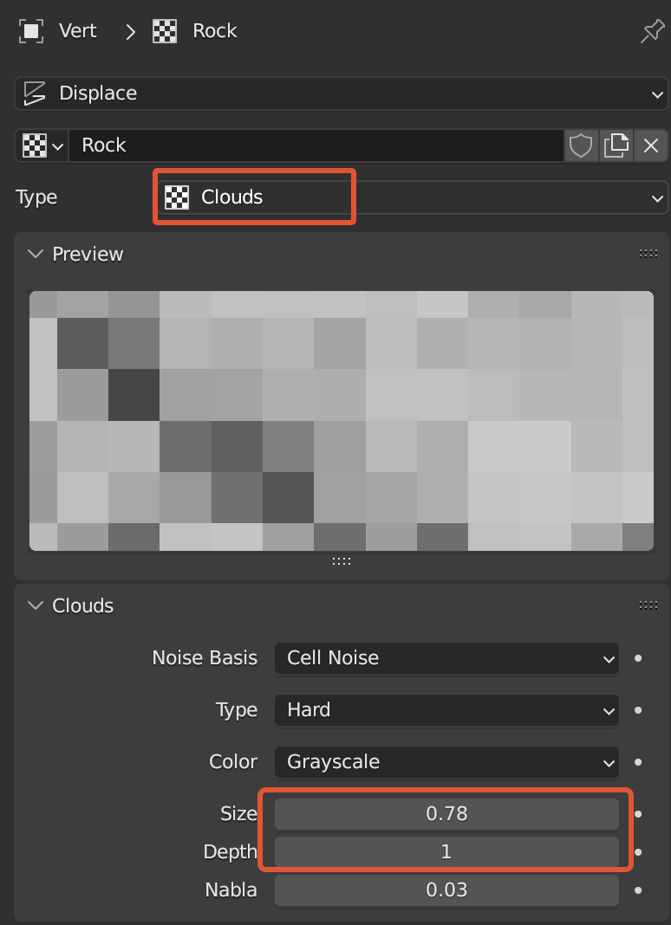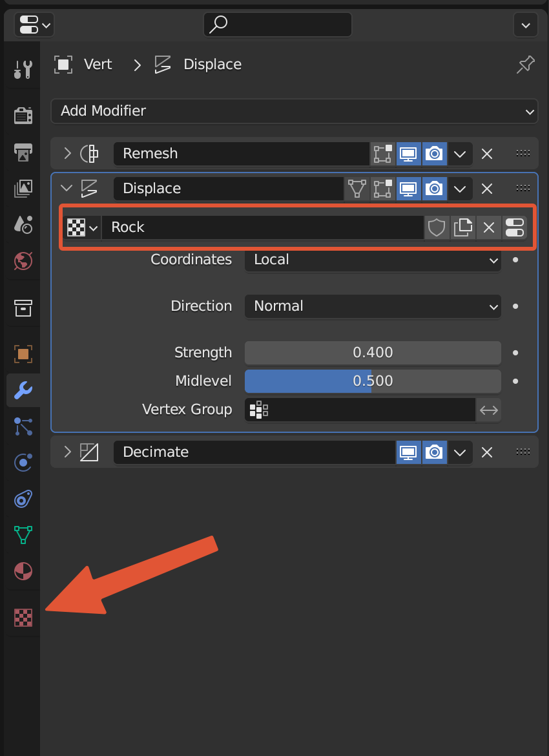

Once there, change the type to “Clouds” and then mess around with the size and depth until you get something you like. It will be pretty detailed which is fine because we’ll reduce the detail in the next step.

You can also go back to the Displace modifier and adjust the “Strength”

Finally add a Decimate modifier. Change it to “Planar” and adjust the angle limit until you get something that looks good.

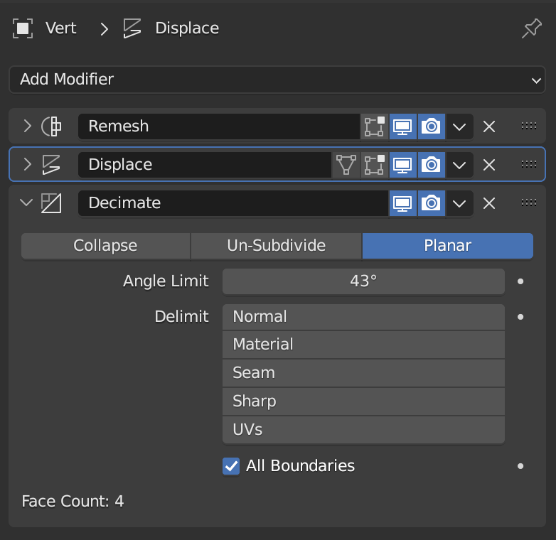

Mess around with every parameter you’ve previously adjusted until you get a result you like.

Optionally you can add a Triangulate modifier, but I found that it looks better without it.

Make sure to enabled **“apply modifiers”** when you export

